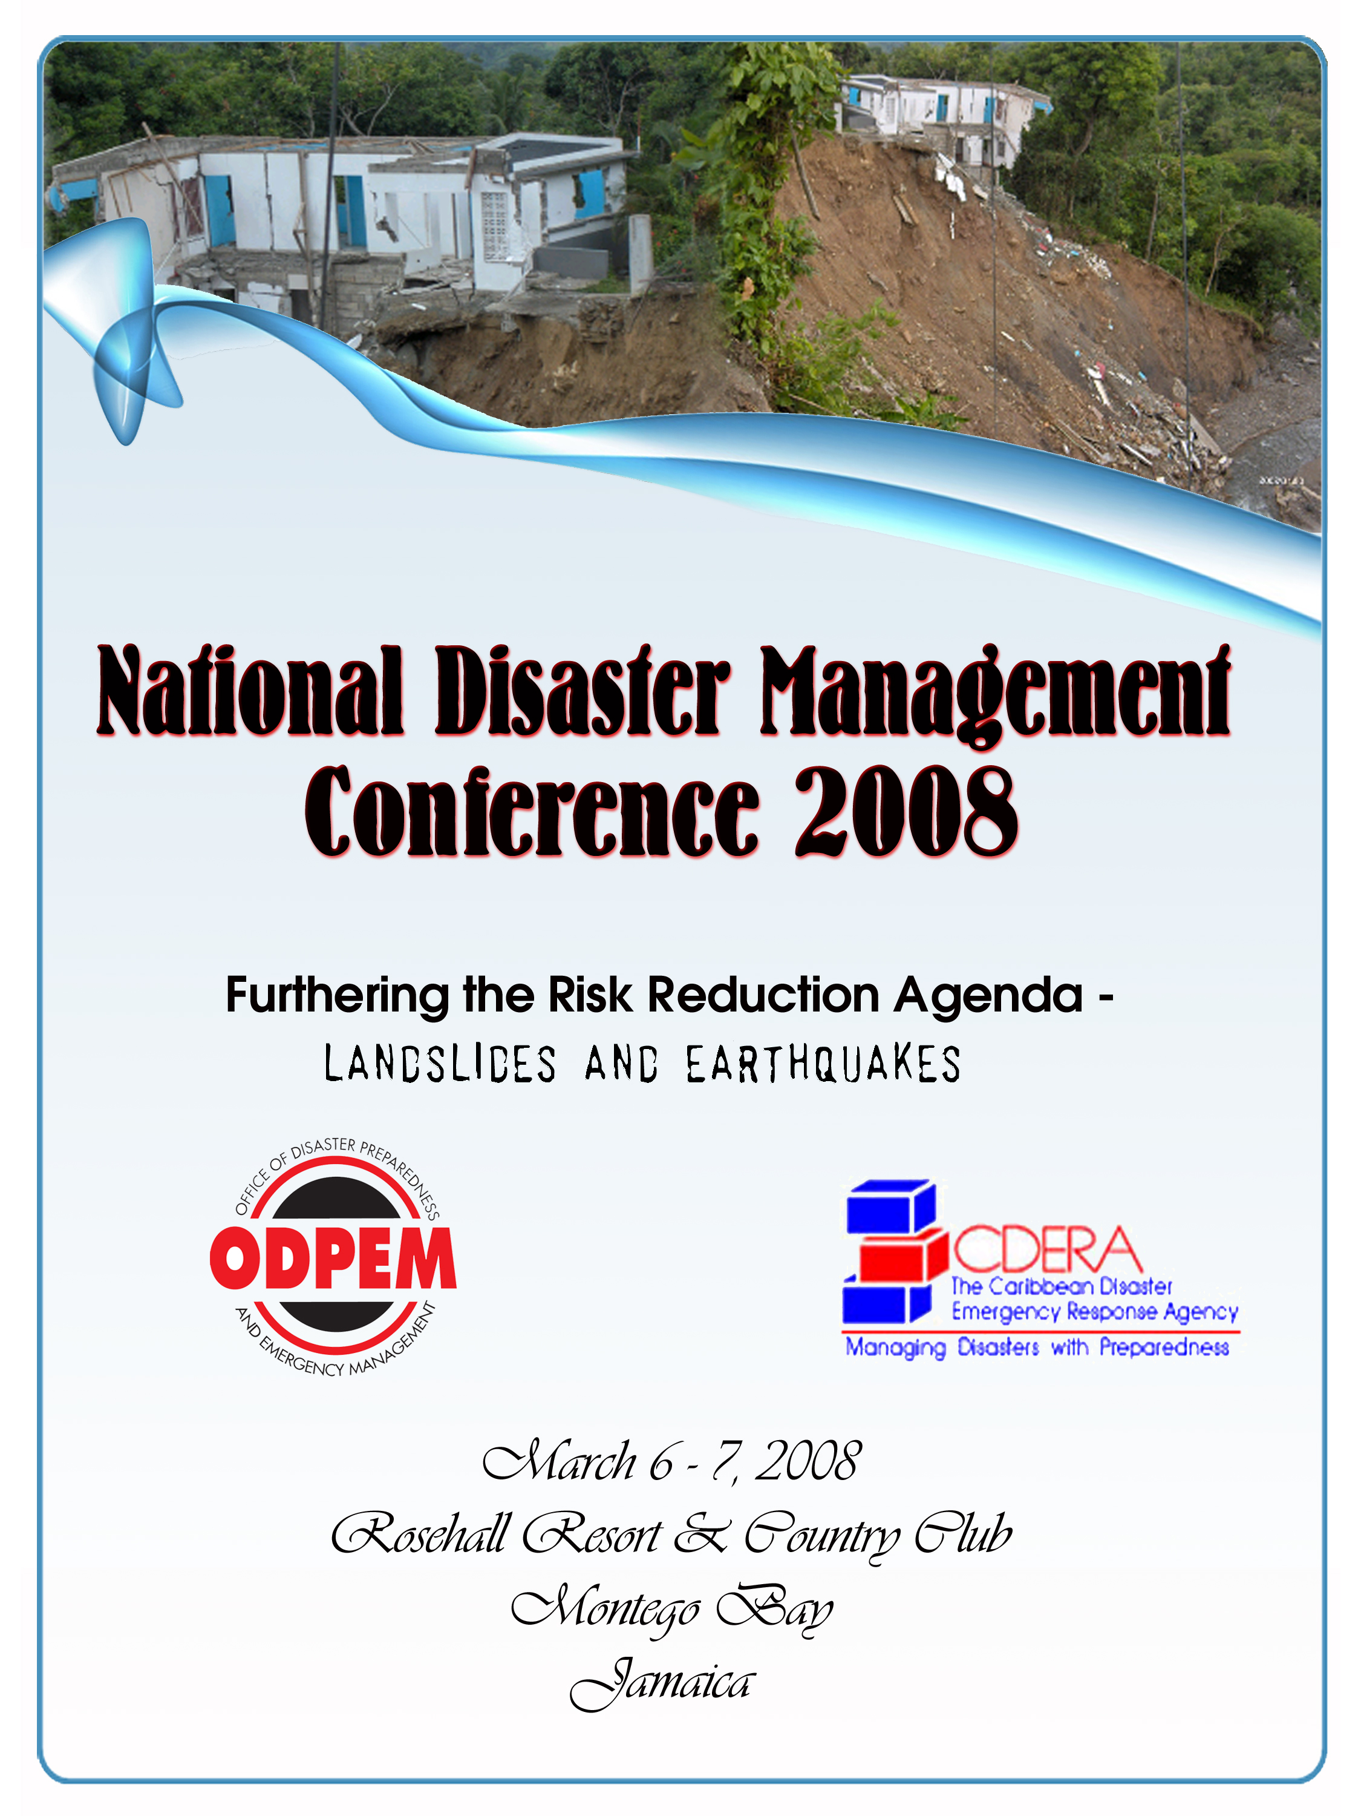

Day 1

8:30 – 10:00 a.m. Registration

10:00 – 10:10 a.m. Welcome
Mr. Ronald Jackson, Director General, ODPEM

10:10 – 10:25 a.m. Greetings

Mr. Philbert Brown, Senior Director, Hazard Management and Weather Services, Local Government Department, Office of the
Prime Minister (OPM)

Mrs. Sandra Martin, Member, Board of Directors, ODPEM

Cllr. Cecil Davis, Deputy Mayor, St. James Parish Council

Mr. Donovan Gentles, Chief Researcher, Caribbean Disaster Emergency Response Agency (CDERA)

Mr. Ronald Jackson, Director General, ODPEM

10:25 – 10:30 a.m. Introduction of Keynote Speaker
Mr. Ronald Jackson, Director General, ODPEM

10:30 – 11:00 a.m. Keynote Address
Dr. Walter D. Mooney, Senior Research Geophysicist Specializing in Earthquakes, Landslides and Tsunami Hazards, United States Geological Survey (USGS)

11:00 – 11:30 a.m. COFFEE BREAK
(Co-Sponsored by the Jamaica Public Service Co. Ltd., T. Geddes Grant (Distributors) Ltd. & the Cement Co. of Jamaica)

11:30 a.m. – 1:00 p.m. Session 1: Learning from Past Events (CONCURRENT PANELS)

Panel 1 - Great Kingston Earthquake of 1907: The Basis for Planning in 2008

Paper 1
Dr. Barbara Carby, Director, Hazard Management Cayman Islands –
Planning for Earthquakes in Jamaica: The Next Steps

Paper 2
Mr. Maurice Mason, Environmental Economist, Institute for Sustainable Development, University of the West Indies (UWI), Mona – A Socio-Economic Impact Assessment of the1907 Earthquake on the 2005 Jamaican Economy

Paper 3
Dr. Parris Lyew-Ayee Jr., Mona GeoInformatics Institute, and Mr. Rafi Ahmad, Head, Unit for Disaster Studies, UWI, Mona – The January 14, 1907 Earthquake: Correlating Shaking Intensity to Geology and Preparation of a “1907 Intensity Shake Map”

Moderator: Mr. Franklin McDonald, Institute for Sustainable Development, University of the West Indies (UWI), Mona, Jamaica

Recorder: Ms. Michelle Edwards, Senior Director, Mitigation, Planning and Research Division (MPRD), ODPEM

Panel 2 – International Experiences: Important Lessons for Jamaica and the Health Sector

Paper 1:
Mr. Christopher Gayle, Research Analyst, ODPEM - The Great Hanshin Awaji Earthquake, Kobe, Japan of 1995: Lessons for Jamaica

Paper 2:
Dr. Homero Silva, PAHO/WHO Representative in Jamaica – Lessons Learnt from a 7.9 Degrees Earthquake in Southern Peru, August 15, 2007

Paper 3:
Dr. Marion Bullock-Ducasse, Director, Emergency, Disaster Management and Special Services, Ministry of Health – Health Preparedness for Mass Casualty Events

Moderator: Mr. Rafi Ahmad, Head, Unit for Disaster Studies

Recorder: Ms. Camille Beckford, Training Officer, ODPEM

1:00 – 2:30 p.m. LUNCH BREAK

2:30 – 4:00 p.m. Session 2: Risk Assessment
(CONCURRENT PANELS)

Panel 1 – Landslide Susceptibility Assessment for Jamaica

Paper 1
Mr. Rafi Ahmad, Head, Unit for Disaster Studies – Landslides in Jamaica

Paper 2
Mr. Norman Harris, Director of Research and Mapping, Mines and Geology Division (MGD), Ministry of Energy, Mining and Telecommunications – Rainfall and Earthquake Induced ‘Mega’ Landslides in Jamaica: Lessons Learnt from Past Events

Paper 3
Mr. Suresh Bhalai, Geologist, Mines and Geology Division (MGD), Ministry of Energy, Mining and Telecommunications – Landslide Susceptibility Assessment and Zonation, Portland, Jamaica

Moderator: Mr. Ronald Jackson, Director General, ODPEM

Recorder: Mr. Christopher Gayle, Research Analysts, ODPEM

Panel 2 – Slope Instability and Earthquakes: Community and National Assessments of the Risks

Paper 1
Dr. Margaret Wiggins-Grandison, Head, Earthquake Unit, University of the West Indies (UWI), Mona – Jamaica: From Seismic Hazard to Seismic Risk

Paper 2
Mrs. Ennika James-Holness, Geologist, Mines and Geology Division (MGD), Ministry of Energy, Mining and Telecommunications – Physical, Psychological and Socio-Economic Impact of Slow Moving Landslides in Two Communities in Jamaica – Applying the Lessons Learnt

Paper 3
Mr. Hopeton Peterson, Manager, Sustainable Development and Regional Planning Division, Planning Institute of Jamaica (PIOJ) – Risk Perception, Land Use Strategies, and Landslide Vulnerability Among Small Farmers: a Preliminary Assessment in the Millbank-Bowden Pen Area

Moderator: Ms. Michelle Edwards, Senior Director, Mitigation, Planning and Research Division (MPRD), ODPEM

Recorder: Ms. Sophia Mitchell, Regional Coordinator, Eastern Region, ODPEM

4:00 - 4:30 p.m. Day 1 Closing Remarks
Mr. Ronald Jackson, Director General, ODPEM

7:00 – 8:00 p.m. COCKTAIL RECEPTION

END OF DAY 1
Day 2

8:30 – 10:00 a.m. Plenary Session 1
Bio-Engineering Methods of Erosion Control and Rehabilitation of Damaged Slopes and Stream Banks Using Coconut Fiber

Panelist: Dr. Justino R. Arboleda, President, Bio-Engineer, Coco Green Technologies, Philippines

Moderator: Mr. Ronald Jackson, Director General, ODPEM

Recorder: Ms. Kerry-Ann Morris, Information Officer, ODPEM

10:00 – 10:30 a.m. COFFEE BREAK
(Co-Sponsored by the Jamaica Public Service Co. Ltd., T. Geddes Grant (Distributors) Ltd. & the Cement Co. of Jamaica)

10:30 a.m. – 12:00 p.m. Session 3: Loss Reduction Strategies
(CONCURRENT PANELS)

Panel 1 - Loss Reduction Strategies for Businesses: The Role of Business Continuity Planning

Paper 1
Mr. Carl McDowell, Risk Manager, National Water Commission (NWC) – Disaster Management at the National Water Commission (NWC)

Paper 2
Mrs. Heather Wallen-Bryan, Business Continuity and Environment Manager, Cable & Wireless Jamaica – The Business Continuity Process in Managing and Reducing Risks at Cable & Wireless, Jamaica (CWJ)

Paper 3
Mr. Bob Harris, Independent Television Producer – The Role of the Media in Risk Reduction

Moderator: Ms. Sophia Mitchell, Regional Coordinator, Eastern Region, ODPEM

Recorder: Ms. Charmaine Gentles, Marketing Manager, ODPEM

Panel 2 – Mitigation Strategies

Paper 1
Mr. Winston Simpson, Land Husbandry Manager, Rural Agriculture Development Agency (RADA) - Slope Stabilization Strategies in the Agriculture Sector

Paper 2
Mr. Damian Graham, GIS Specialist, Ministry of Agriculture and Land - A Critical Evaluation of Earthquake Loss Estimation Models and Their Potential Application to the Caribbean Region

Paper 3:
Mr. Julien Houel, Geotechnical Engineer, General Council of Martinique - Landslide Stabilization in Martinique

Moderator: Mr. Hopeton Peterson, Manager, Sustainable Development and Regional Planning Division, Planning Institute of Jamaica (PIOJ)

Recorder: Mrs. Ennika James-Holness, Geologist, Mines and Geology Division (MGD), Ministry of Energy, Mining and Telecommunications

12:00 – 1:30 p.m. LUNCH BREAK

1:30 – 3:30 p.m. Plenary Session 2
Regional Experiences in Landslide and Earthquake Planning and Mitigation (Sponsored by the Caribbean Disaster Emergency Response Agency [CDERA])

Paper 1
Ms. Shelly Pile, Programme Officer, Caribbean Disaster Emergency Response Agency (CDERA) - Putting Earthquakes Readiness on the Regional Agenda: CDERA and Comprehensive Disaster Management (CDM)

Paper 2
Mr. Ronald Jackson, Director General, ODPEM – An Assessment of the National Response Capacity for a Large Magnitude Earthquake

Paper 3
Ms. Judy Thomas, Director, Department for Emergency Management, Barbados - Barbados' Country Report of Earthquake Readiness

Paper 4
Mr. Kareem Mack, Building Inspector, Development and Control Authority, Ministry of Works, Antigua and Barbuda - Earthquake Vulnerability in Antigua & Barbuda
Paper 5
Mr. John C. St. Louis, Senior Engineer, Ministry of Works, Communication and Transport, Grenada - Grenada's Earthquake Readiness Capacity

Paper 6
Mr. Perryette Peets, Deputy National Disaster Coordinator, National Emergency Management Agency (NEMA), St. Kitts and Nevis – “Tremble It!” Are we Countering or Countenancing the Calypso Culture for Courting Danger?

Moderator: Mr. Donovan Gentles, Chief Research Officer, Caribbean Disaster Emergency Response Agency (CDERA)

Recorder: Mr. Christopher Gayle, Research Analyst, ODPEM

3:30 – 5:00 p.m. Plenary Session 3
The Jamaican Response: An Examination of the Current Response Strategies, Gaps and Challenges

Paper 1
Michelle Edwards, Senior, Director Mitigation, Planning and Research Division, ODPEM - An Effective and Efficient Earthquake Response Process: The Role of Damage Assessment

Paper 2
Ms. Camille Beckford, Training Officer, ODPEM - Preparing Our Nation’s Children for the Next Big Quake

Paper 3
Jamaica Fire Brigade (JFB) – The Search and Rescue Capacity of the Jamaica Fire Brigade for Mass Casualty Events

Moderator: Dr. Barbara Carby, Director, Hazard Management Cayman Islands

Recorder: Ms. Kerry-Ann Morris, Information Officer, ODPEM

5:00 – 5:30 p.m. Session 6: Closing Session

Summary of Conference and Closing Remarks
Mr. Ronald Jackson, Director General, ODPEM

